**LED Bulb 4W B22 Golf Bulb G45 cap**

SKU: T525 – 3000k | T526 – 6500k

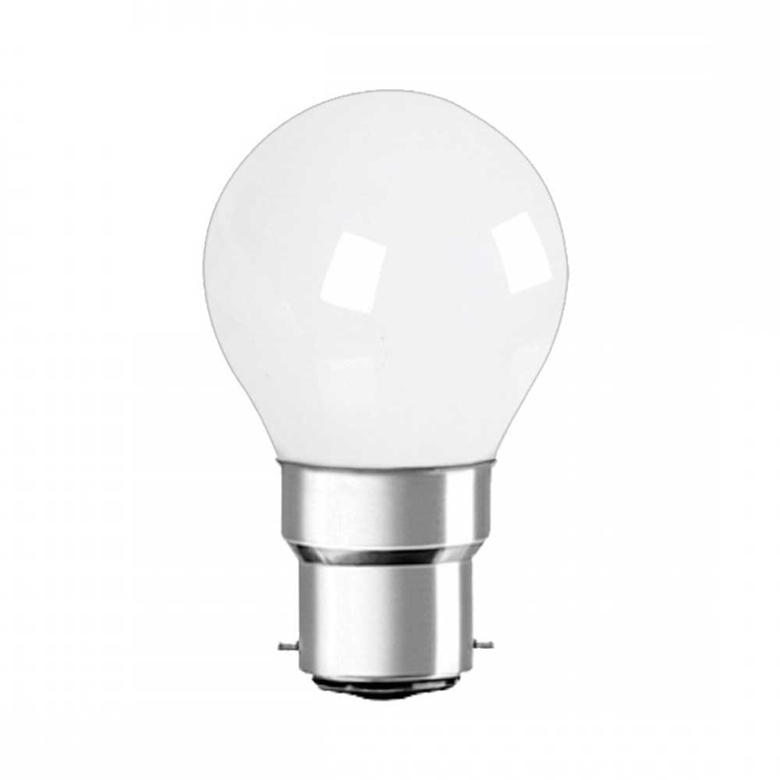

**Features**

* **Energy Saving:** Replace 35W incandescent bulb with 4W LED, save 88% on electricity bill of lighting.
* **Perfect Lighting:** Instant on, gives off 300lm comfortable warm light, creating a relax atmosphere in any room.
* **Easy to Install:** Fits well into your B22 bayonet lamp holder, and easy to replace old incandescent or CFL light bulb.
* **Extremely Long Life:** Lasts up to 15,000 hours, reduces the hassle of re-lamp frequency.
* **What You Will Get:** 6 x Non-dimmable B22 G45 LED bulbs, and a lifetime of our friendly customer service.

**Specification**

|  |  |
| --- | --- |
| SKU | T525 – 3000k  T526 – 6500k |
| Product Weight | 132 g |
| Product Dimensions | 21.5 x 9.3 x 5.2 cm |
| Area Lighting Classification | IP20 |
| Shape | Golf Ball |
| Material | Plastic |
| Voltage | 175-245V |
| Type of Bulb | LED |
| Cap Type | B22 |
| EU Energy Efficiency Label | A+ |
| Luminous Flux | 300 lumen |
| Wattage | 4 watts |
| Incandescent Equivalent | 35 watts |
| Bulb Features | Instant On |
| Colour Temperature | T525 – 3000k  T526 – 6500k |
| Colour Rendering Index (CRI) | 80.00 |
| Average Life | 50000 hours |
| Bulb Diameter | 45 millimeters |
| Bulb Length | 75 millimeters |